WHICH IS THE VEGAN ONE?

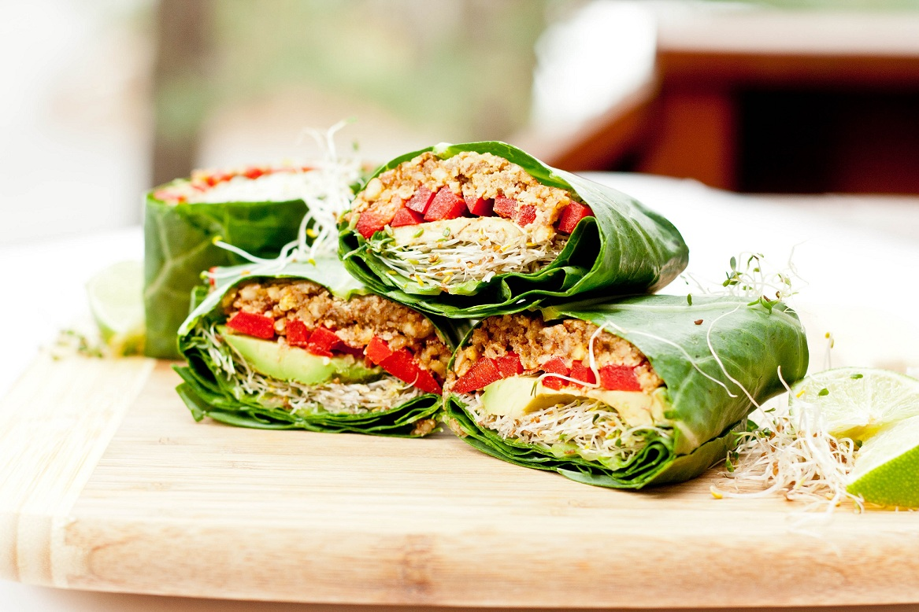
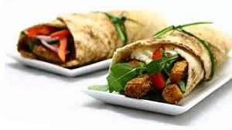
Lunch Wrap

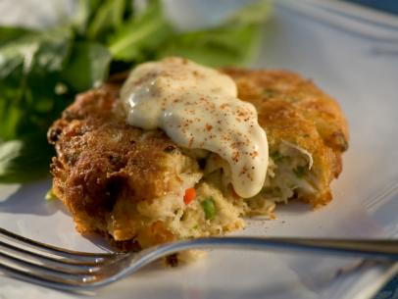
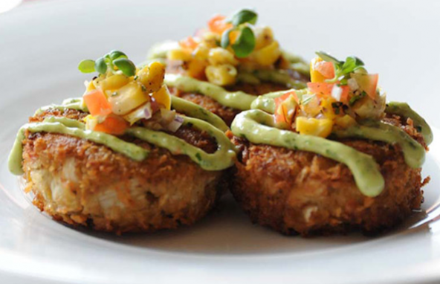
Crab Cakes

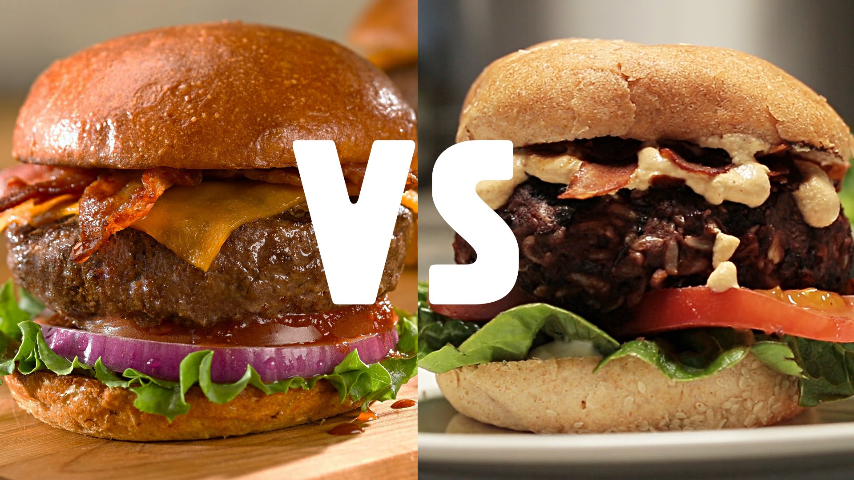
Burgers

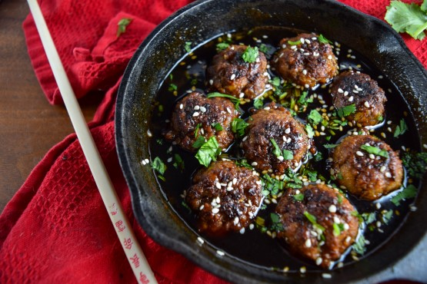
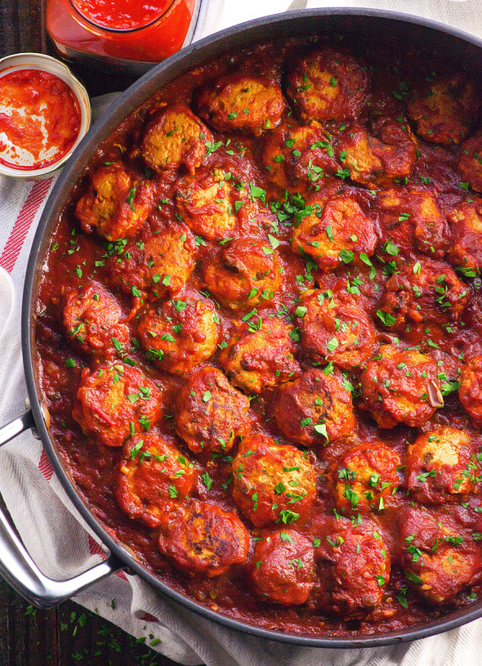
WHICH IS THE FASTER TO PREPARE ONE?
Meatballs

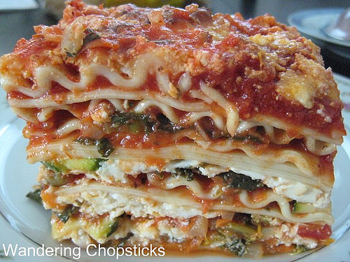
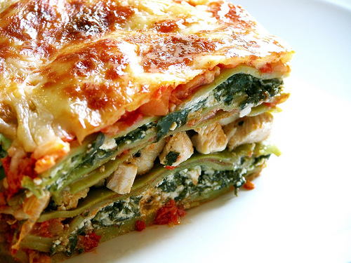

Lasagna

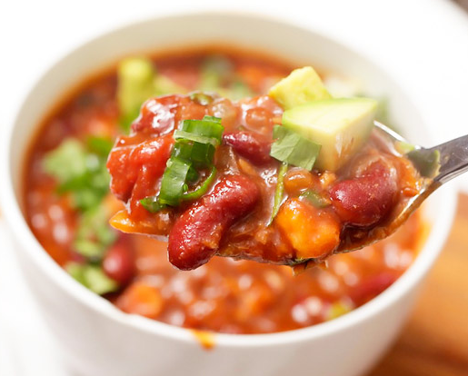
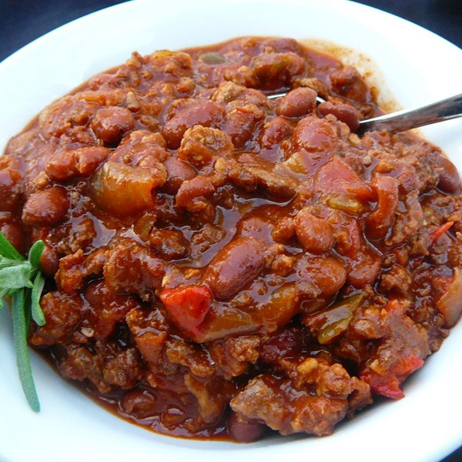
Chili

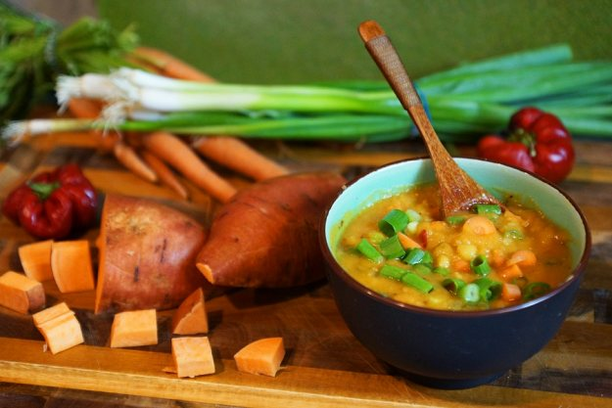
WHICH ONE IS LESS EXPENSIVE?
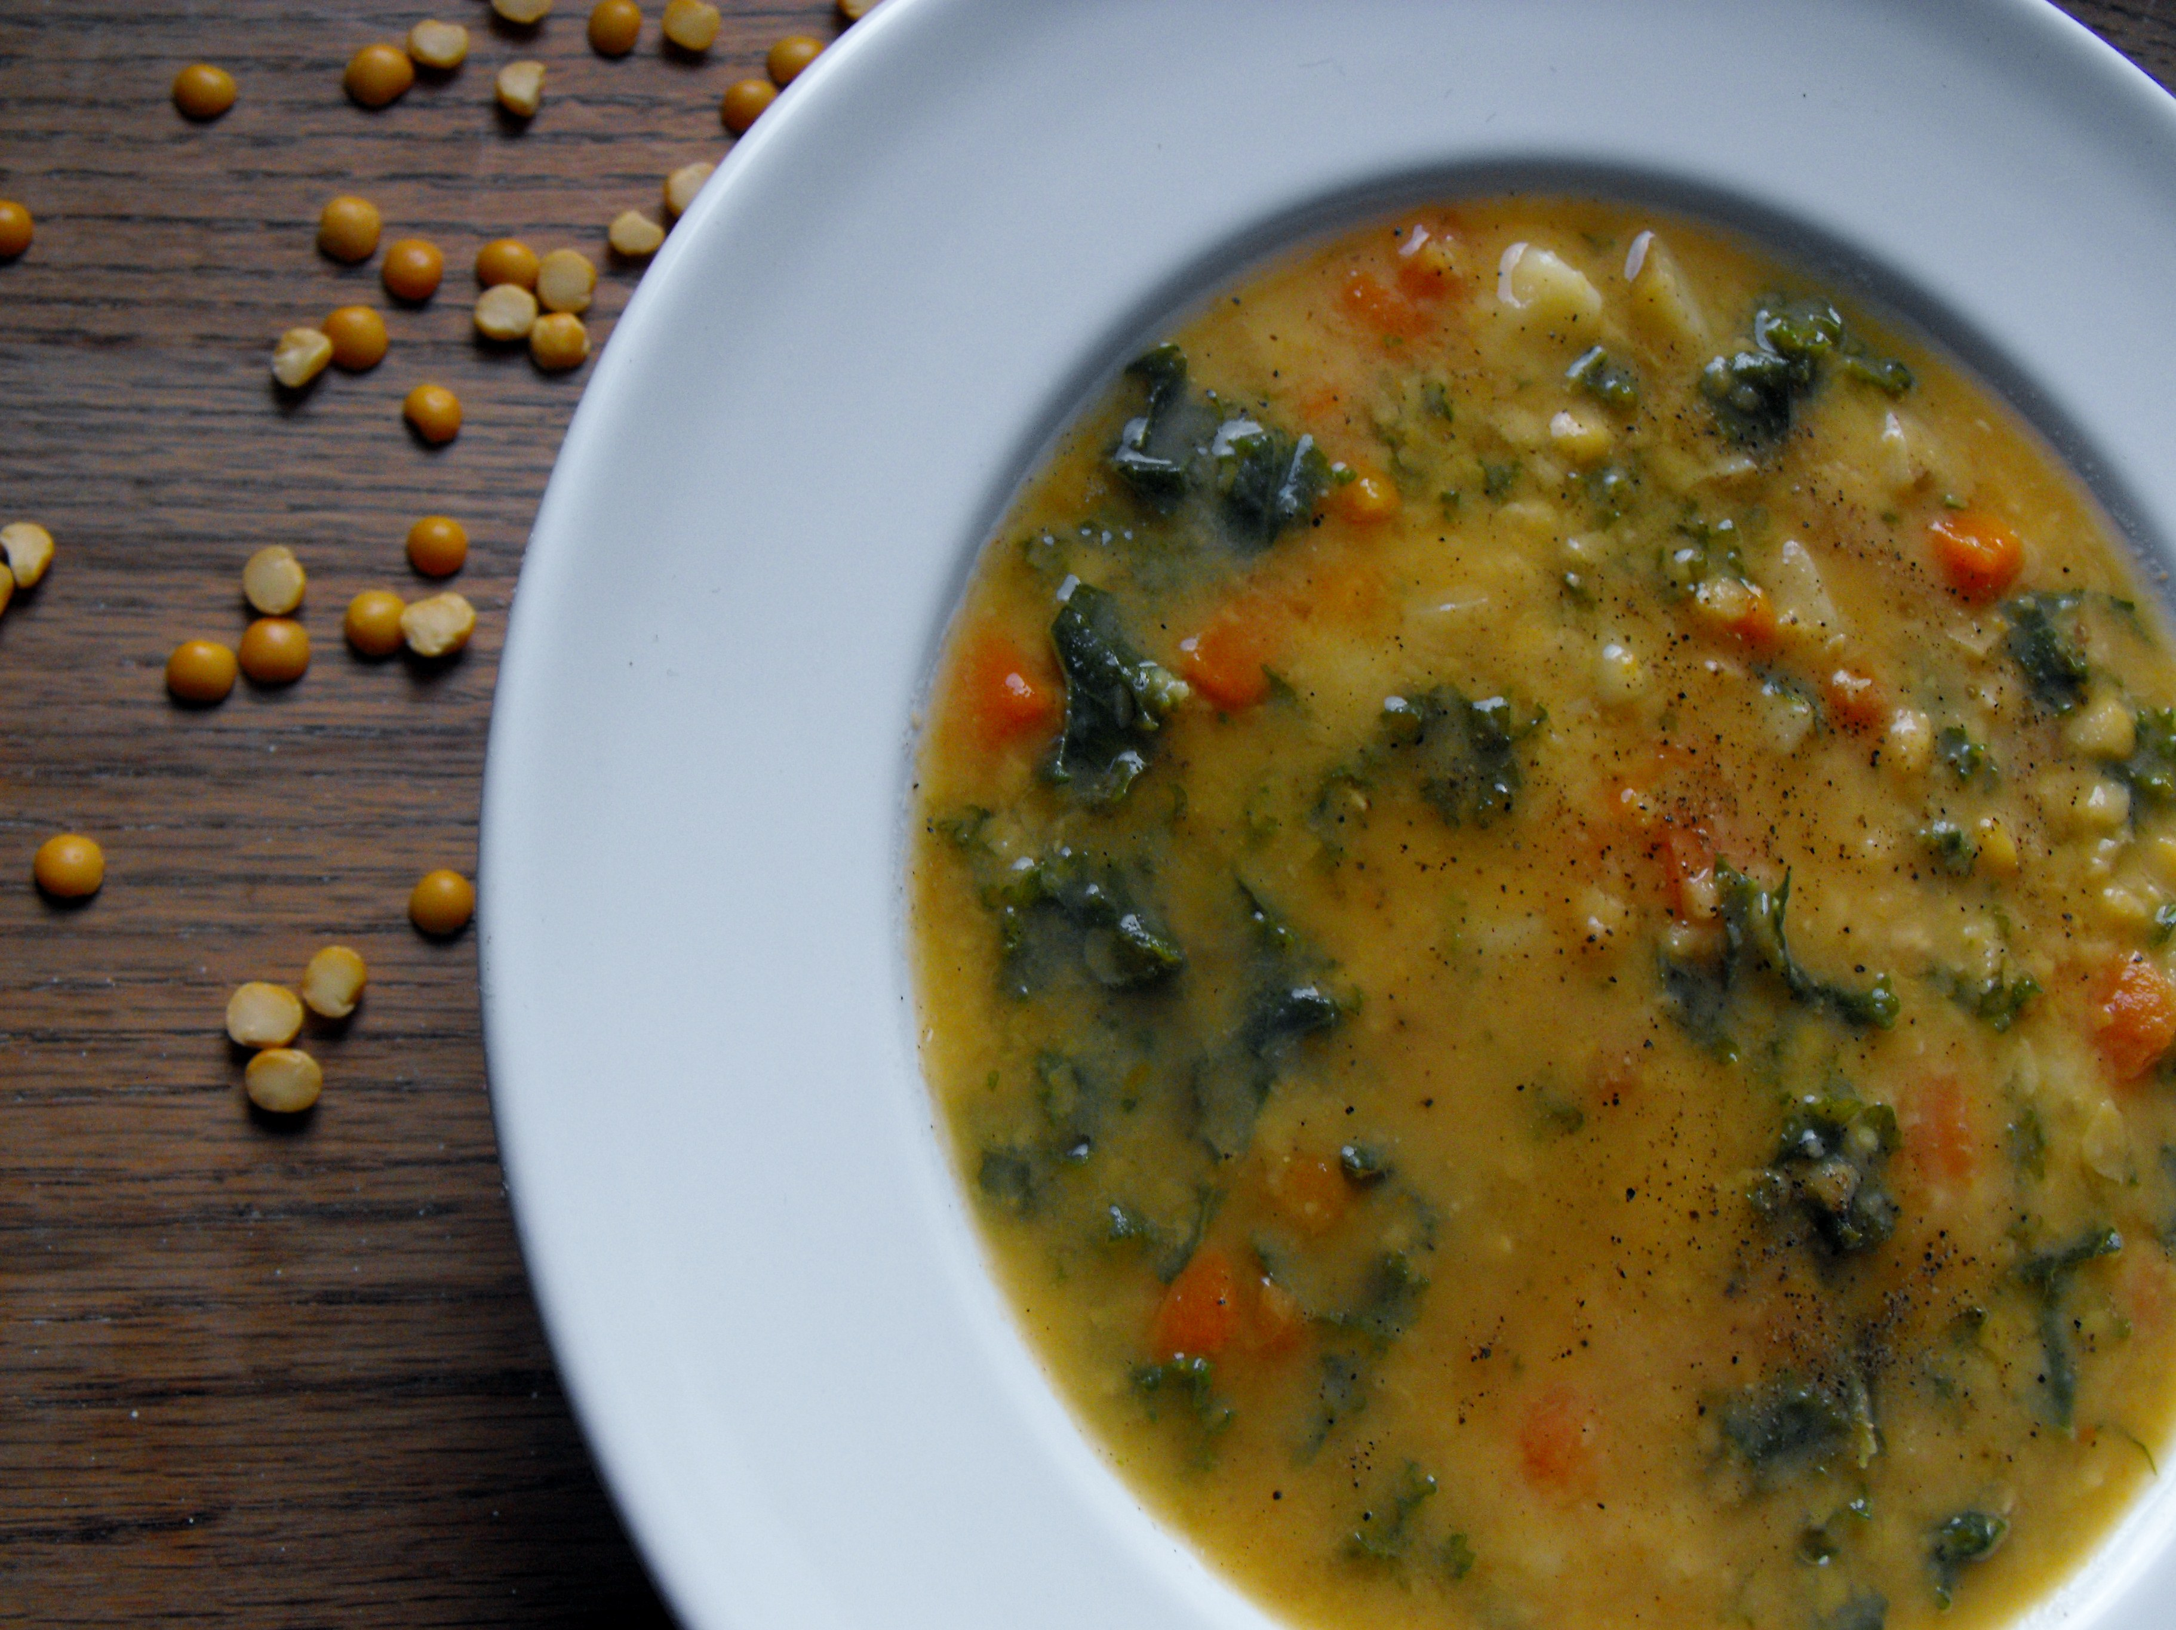
Split Pea Soup
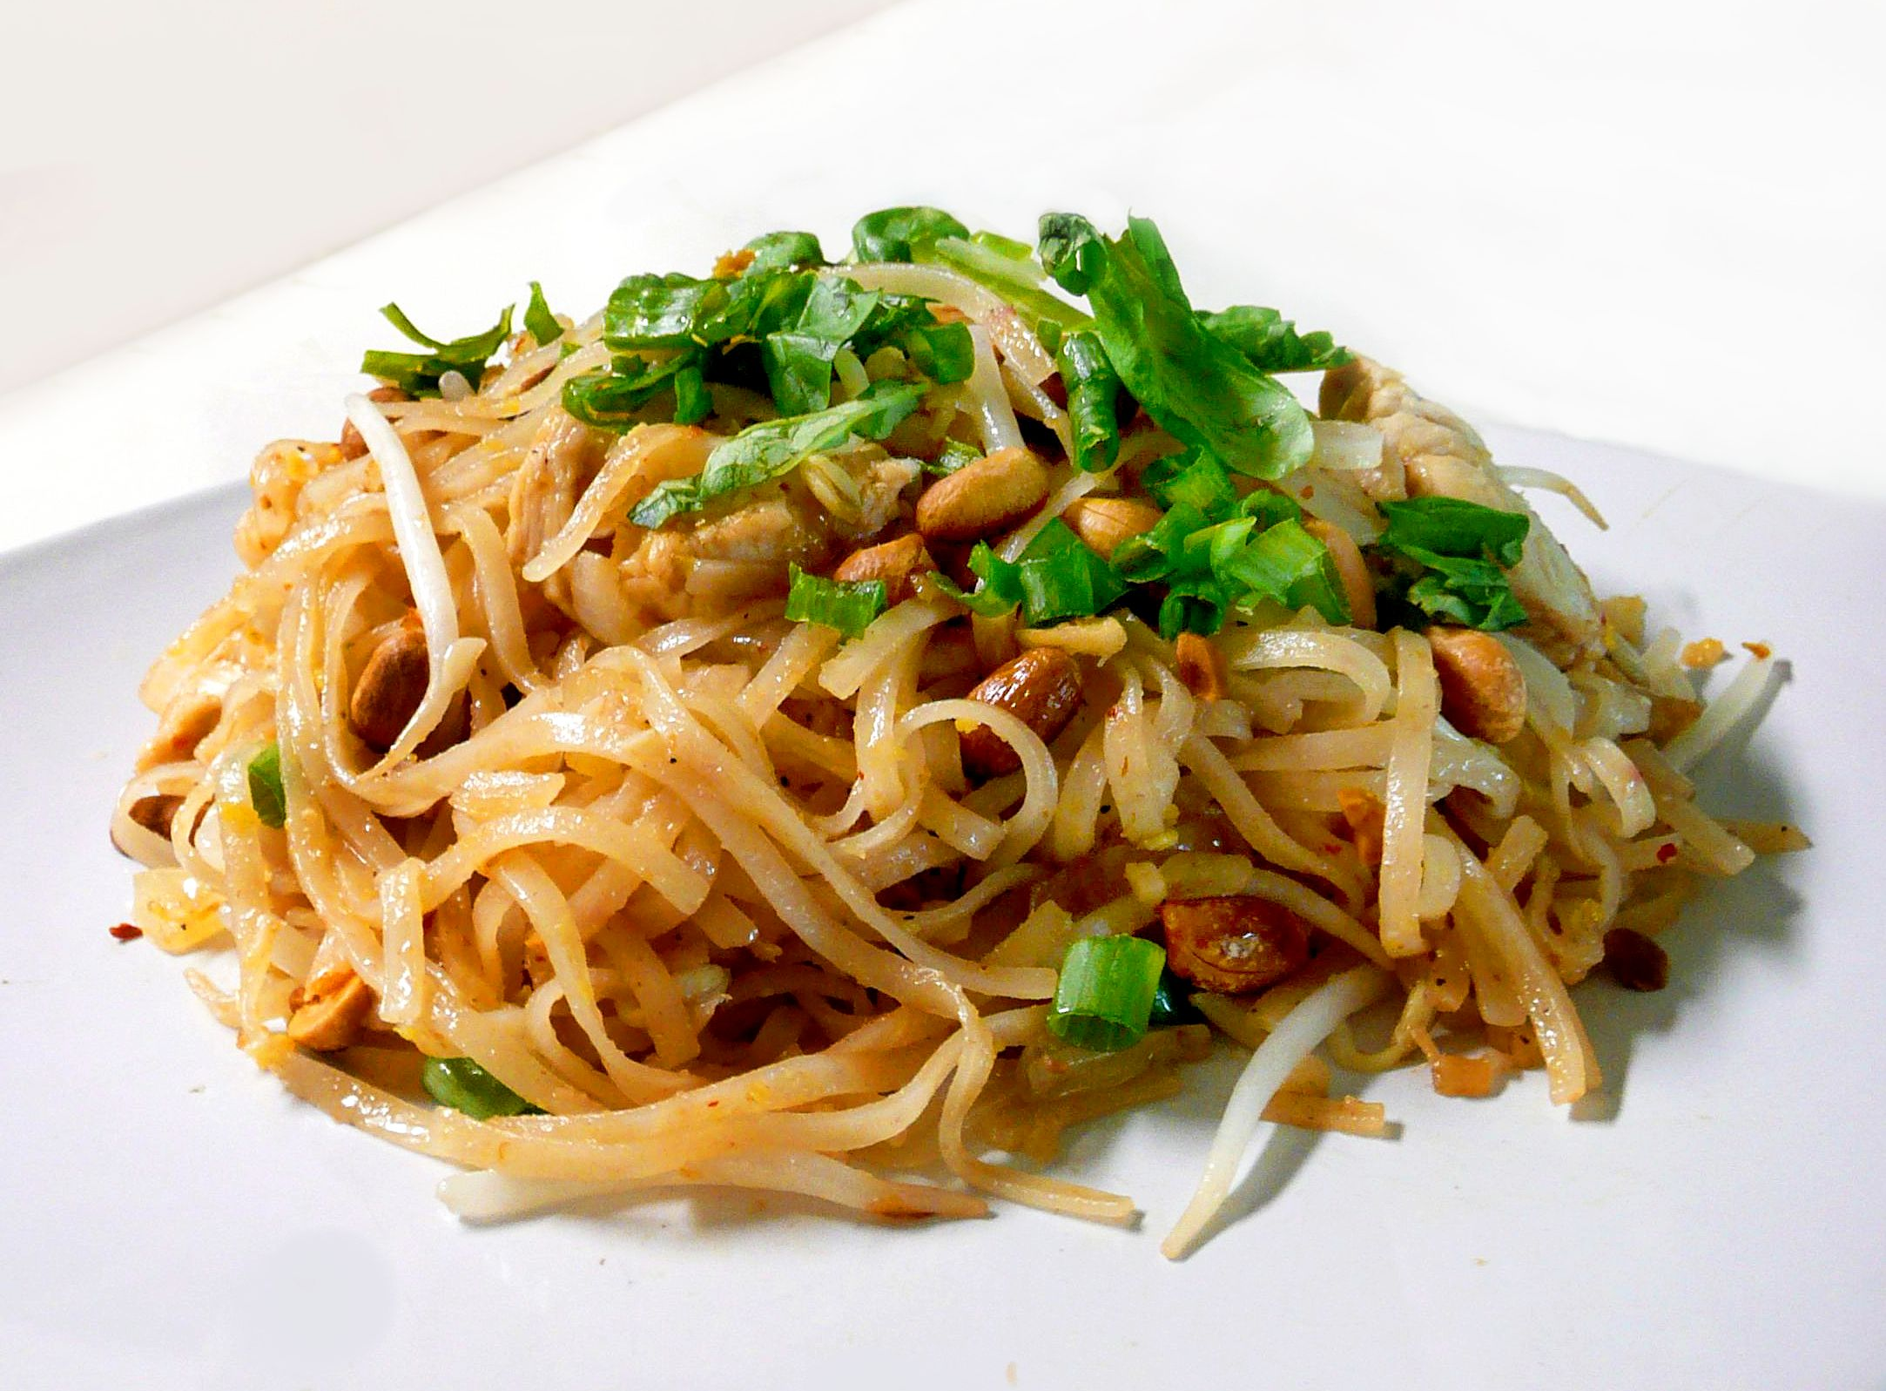


Pad Thai

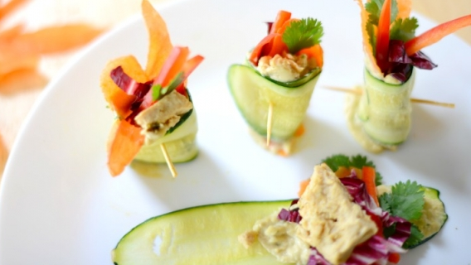
Zucchini Roll Amuse-bouche
WHICH IS THE LOW-CALORIE ONE?

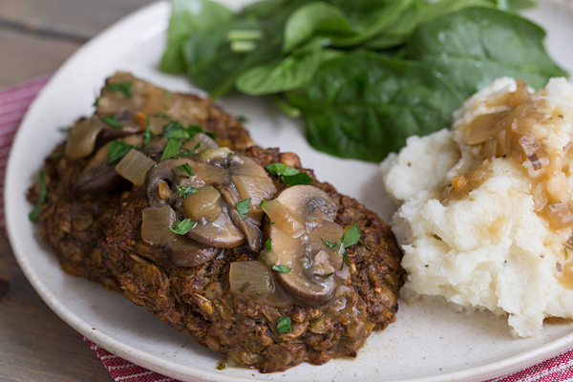
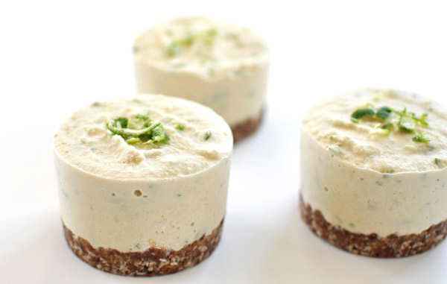
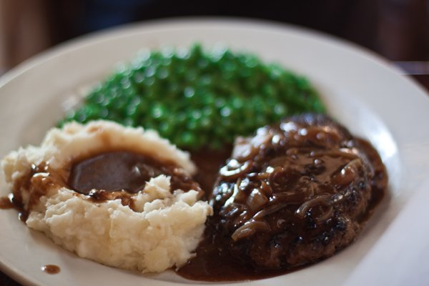Salisbury Steak

Cheesecake Bites

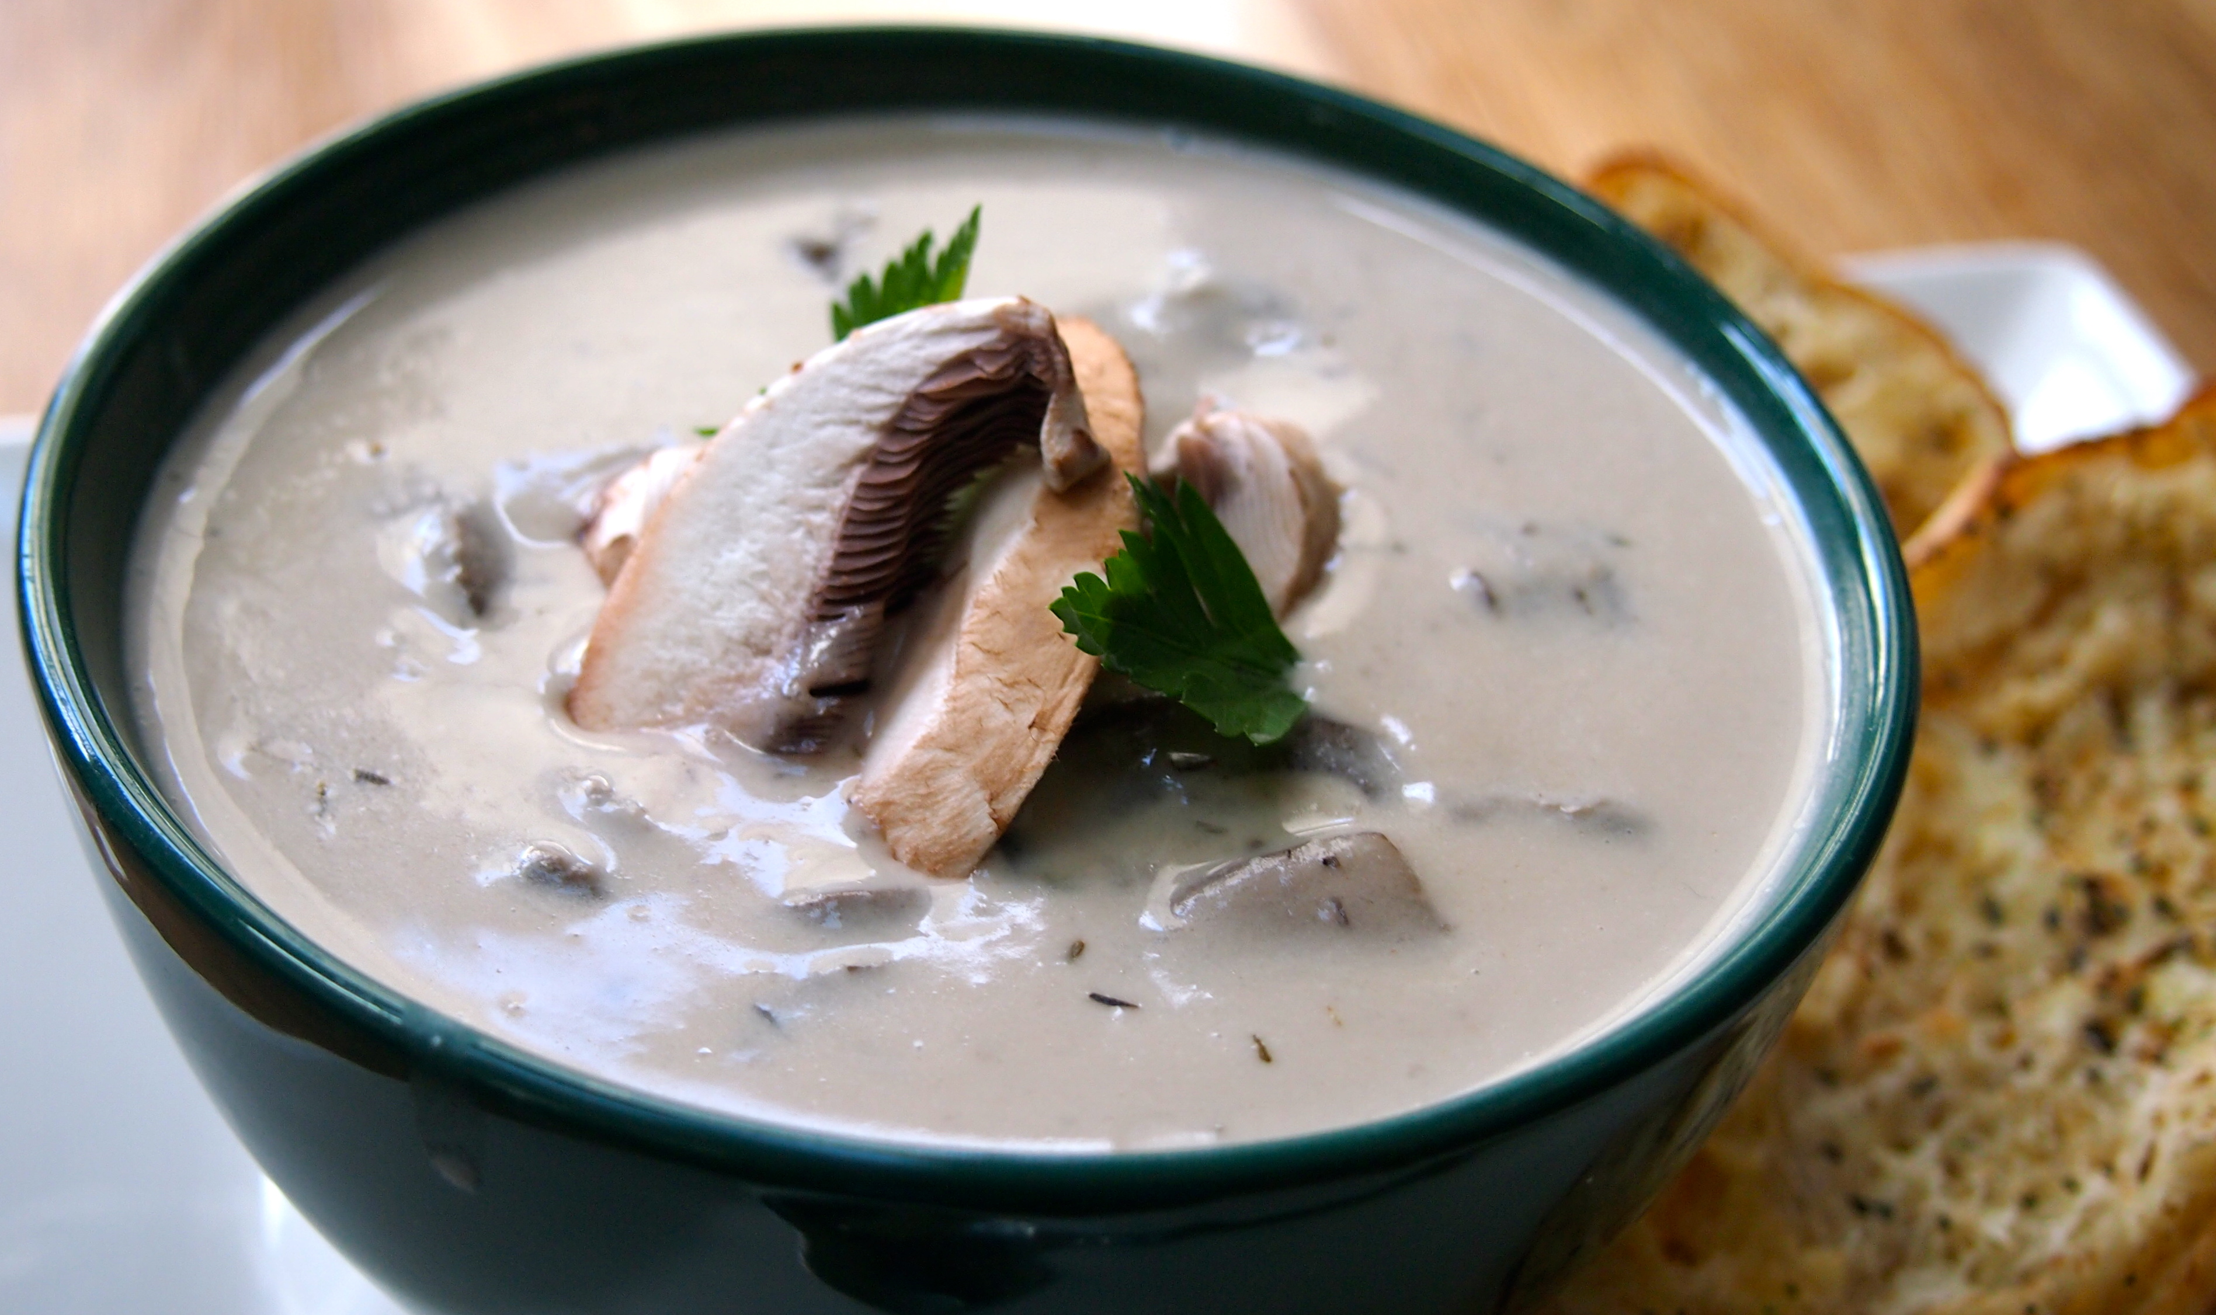
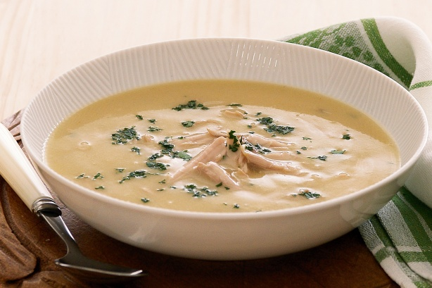
Cream Soup

WHICH TASTES BETTER (WON SIGNIFICANT AWARD)?
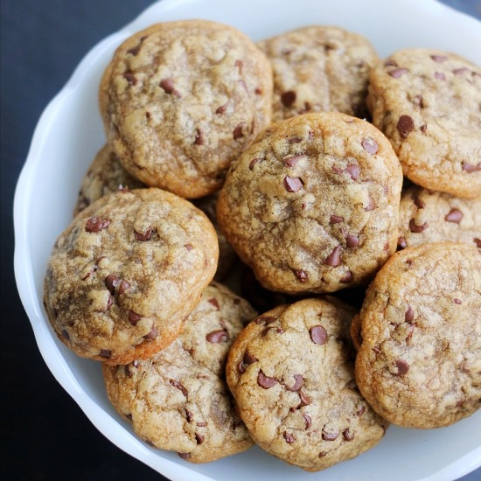
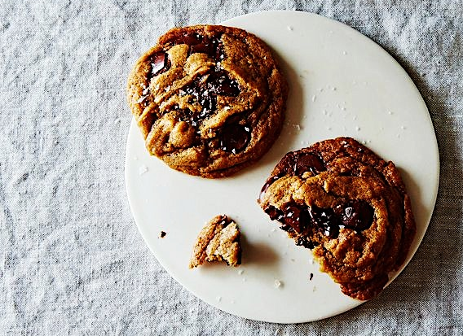

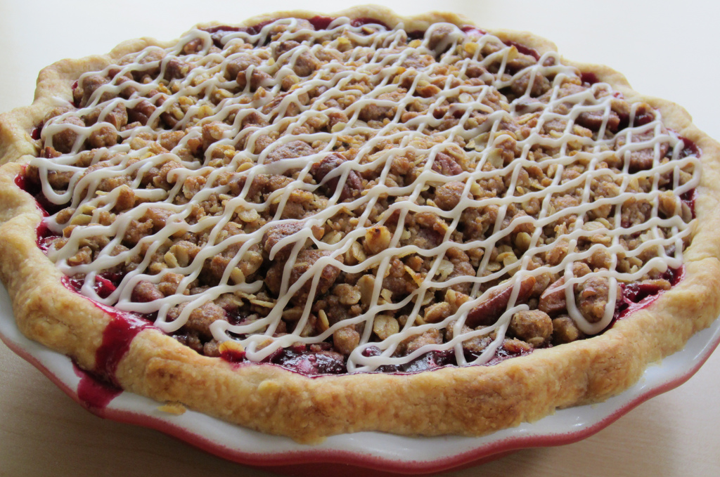
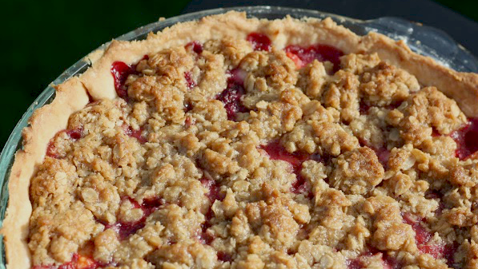
Chocolate Chip Cookies

Berry Pie
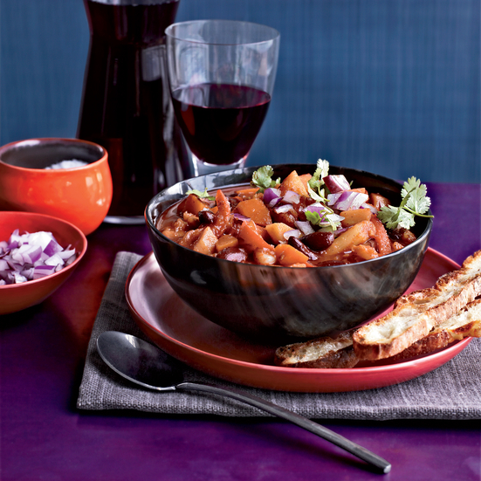


Chili
ANSWERS

Is it Vegan?
- Trick. They are both vegan.
  - Vegan Chicken Wrap
  - Collard Green Hummus Wrap
- A is a vegan crab cake.
- B is a vegan bacon cheeseburger

Which is faster to prepare?
- A is vegan, and faster to prepare.
  - 15 minutes prep and 30 min cook
  - 30 min prep and 45 min cook
- B is vegan, and faster to prepare.
  - Separate process for chicken, with 35 min prep, a 15 minute sauté and a one hour bake time.
  - Assemble in 20 min, and bake for 45 minutes.
- B is vegan, and faster to prepare.
  - Crock pot on low 8 hours, high for 4
  - Crock pot on low for 7 hours or high for 3

Which is less expensive?
- B is vegan, and is less expensive.
  - Ham and meat stock adds $2 per serving, to over $4.
  - At less than $2 total per serving, the cost can be further reduced if stock from vegetable scraps is made at home.
- A is vegan, and is similar in price but slightly cheaper.
  - Tofu instead of chicken, omitting the egg and fish oil saves just under $1 per serving.
  - Chicken can be similar or slightly more expensive than tofu in price, but the egg will be another .30-50 cents, and the fish oil expensive and difficult to find.
- B is vegan, and is less expensive.
  - The prosciutto and cheese more than triple the price to $2 per bite at home, or up to $4 at a restaurant.
  - At home cost of $1 or less per bite, and up to $2 out.

Which is lower in calories?
- A is vegan, and has fewer calories.
  - The seitan steak, and gravy with mushrooms comes in under 300 calories for a hefty portion, under 8 grams of fat, and with only 2 grams less protein than a steak of similar size. The sides are leaner too.
  - The traditional Salisbury steak at home comes in near 700 calories, over 26 grams of fat, and 19 grams of protein, even though the portion is much smaller than its vegan counterpart.
- B is vegan, and has fewer calories.
  - The new york cheesecake bites each come in at 125 calories, with 5 grams of fat, and 1 gram of protein.
  - The vegan coconut lime cheesecake bites come in at 75 calories, 2.5 grams of fat, and 2 grams of protein.
- A is vegan, and has fewer calories.
  - While thick and creamy, this soup has 260 calories per serving and no saturated fat.
  - The creamy soup has 550 calories per serving, and 9 grams of fat, 4 of which are saturated fats.

Which was voted better and won (not in vegan contests)?
- A is vegan, and won the Food52 Chocolate Chip Cookie Challenge.
- B is vegan, and won at the Orange County Fair.
- Trick. These are both vegan.
  - A won the Honolulu Chili Cook Off
  - Gourmet magazine’s top pick for winter meals.

